**SQL QUERY EXECUTION assignment I**

This example I used in executing the query I got it from the internet while trying to learn more about the syntax of query

**1. Codes for creating tables**

-- Create Departments Table

CREATE TABLE Departments (

department_id NUMBER PRIMARY KEY,

department_name VARCHAR2(100)

);

-- Create Employees Table with a foreign key relationship to Departments

CREATE TABLE Employees (

employee_id NUMBER PRIMARY KEY,

first_name VARCHAR2(100),

last_name VARCHAR2(100),

hire_date DATE,

department_id NUMBER,

FOREIGN KEY (department_id) REFERENCES Departments(department_id)

);

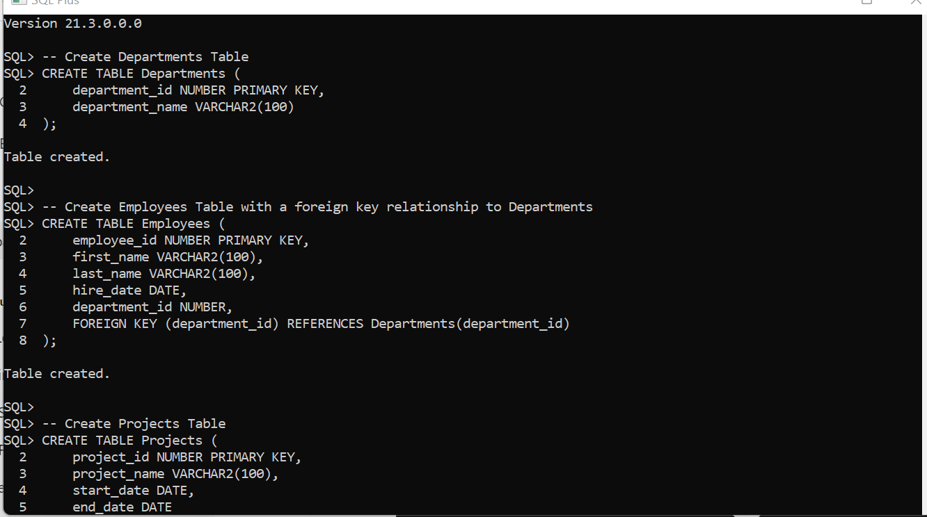

-- Create Projects Table

CREATE TABLE Projects (

project_id NUMBER PRIMARY KEY,

project_name VARCHAR2(100),

start_date DATE,

end_date DATE

);

-- Create Salaries Table with foreign key to Employees

CREATE TABLE Salaries (

salary_id NUMBER PRIMARY KEY,

employee_id NUMBER,

salary_amount NUMBER,

pay_date DATE,

FOREIGN KEY (employee_id) REFERENCES Employees(employee_id)

);

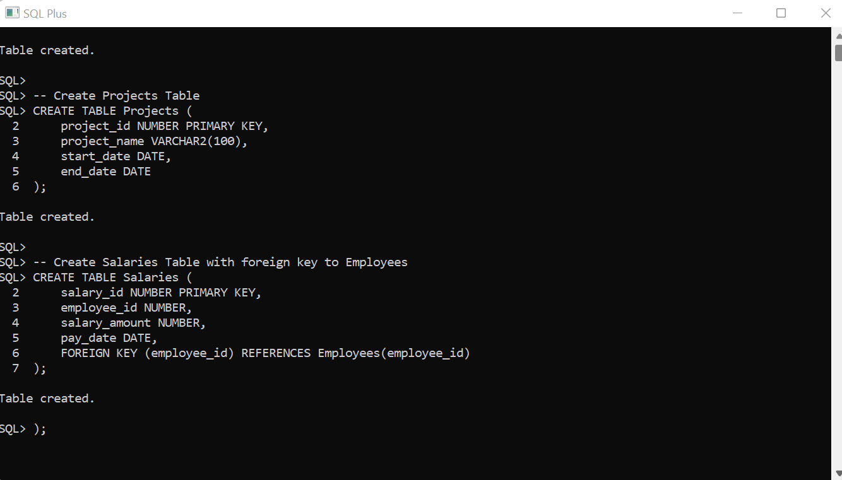

**2. inserting data**

-- Insert into Departments

INSERT INTO Departments (department_id, department_name)

VALUES (1, 'HR');

INSERT INTO Departments (department_id, department_name)

VALUES (2, 'Finance');

INSERT INTO Departments (department_id, department_name)

VALUES (3, 'Accounting');

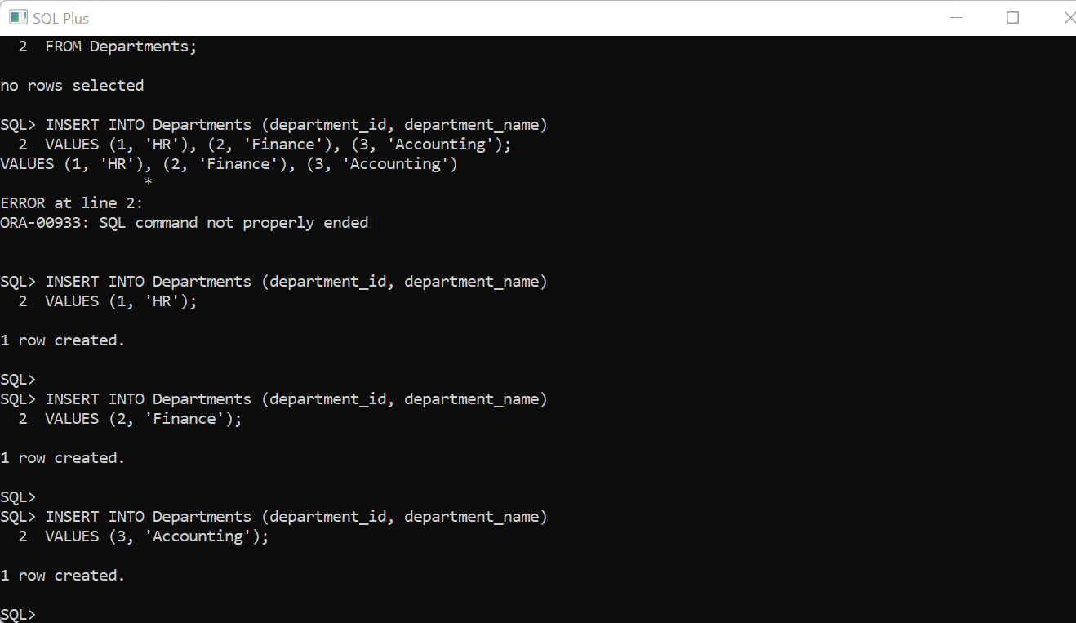

**-- Insert into Employees**

-- Insert the first employee

INSERT INTO Employees (employee_id, first_name, last_name, hire_date, department_id)

VALUES (101, 'John', 'Doe', TO_DATE('2021-01-15', 'YYYY-MM-DD'), 1);

-- Insert the second employee

INSERT INTO Employees (employee_id, first_name, last_name, hire_date, department_id)

VALUES (102, 'Jane', 'Smith', TO_DATE('2020-03-22', 'YYYY-MM-DD'), 3);

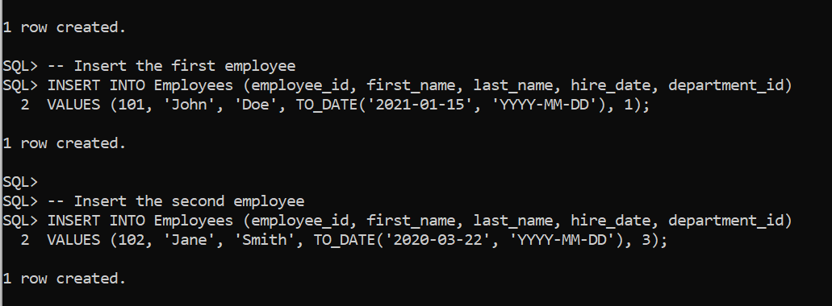

-- Insert into Projects

INSERT INTO Projects (project_id, project_name, start_date, end_date)

VALUES (201, 'Database Migration', TO_DATE('2023-05-10', 'YYYY-MM-DD'), TO_DATE('2023-09-30', 'YYYY-MM-DD'));

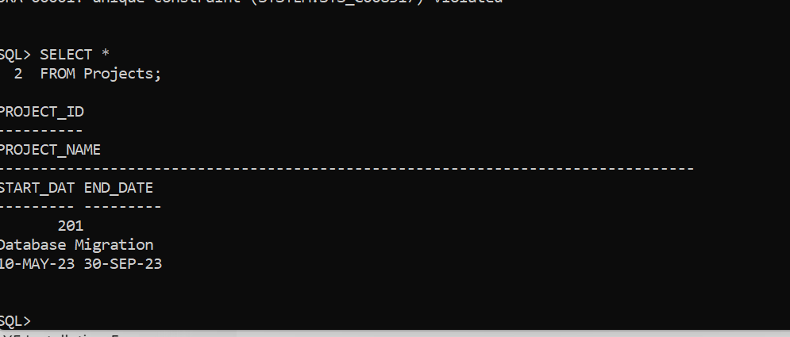

-- Insert into Salaries

-- Insert the first salary

INSERT INTO Salaries (salary_id, employee_id, salary_amount, pay_date)

VALUES (301, 101, 5000, TO_DATE('2023-09-01', 'YYYY-MM-DD'));

-- Insert the second salary

INSERT INTO Salaries (salary_id, employee_id, salary_amount, pay_date)

VALUES (302, 102, 7000, TO_DATE('2023-09-01', 'YYYY-MM-DD'));

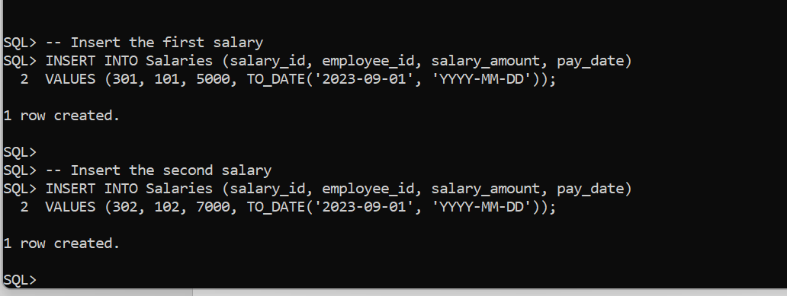

**3.update and delete**

-- Update an employee's salary

UPDATE Salaries

SET salary_amount = 5500

WHERE employee_id = 101;

-- Delete a project

DELETE FROM Projects

WHERE project_id = 201;

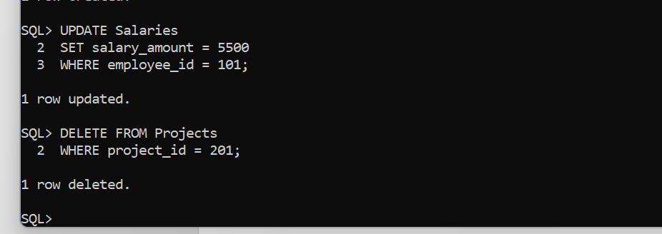

**4. perform joins**

1. **Inner join**

-- Join Employees with Departments to get employee names and their departments

SELECT e.first_name, e.last_name, d.department_name

FROM Employees e

INNER JOIN Departments d

ON e.department_id = d.department_id;

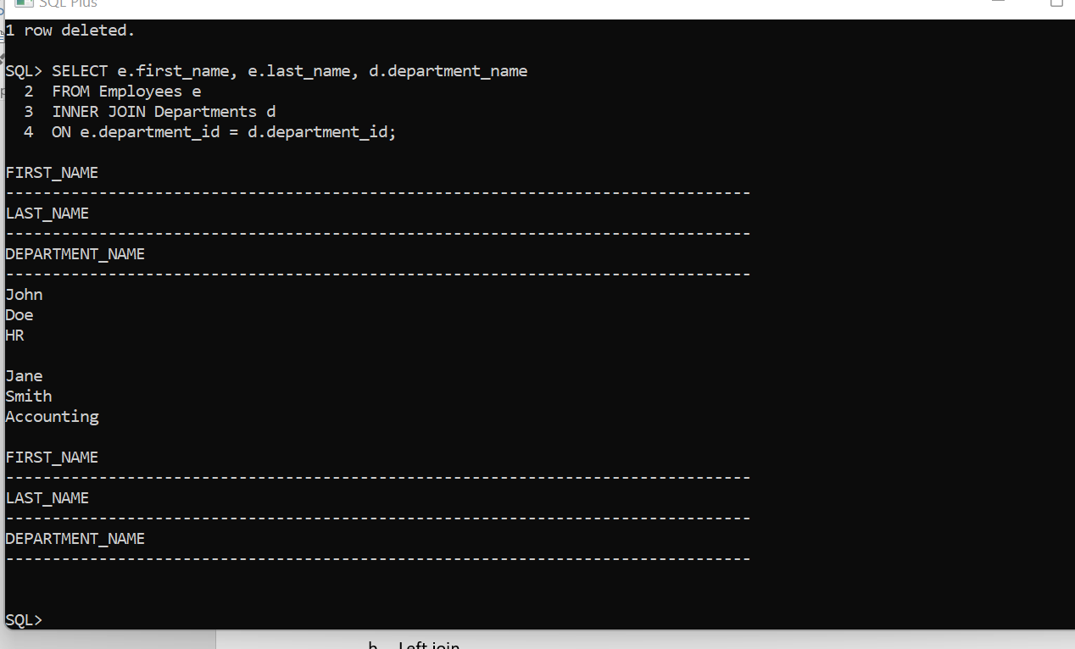

1. **Left join**

-- Retrieve all employees, including those who may not be assigned to a department

SELECT e.first_name, e.last_name, d.department_name

FROM Employees e

LEFT JOIN Departments d

ON e.department_id = d.department_id;

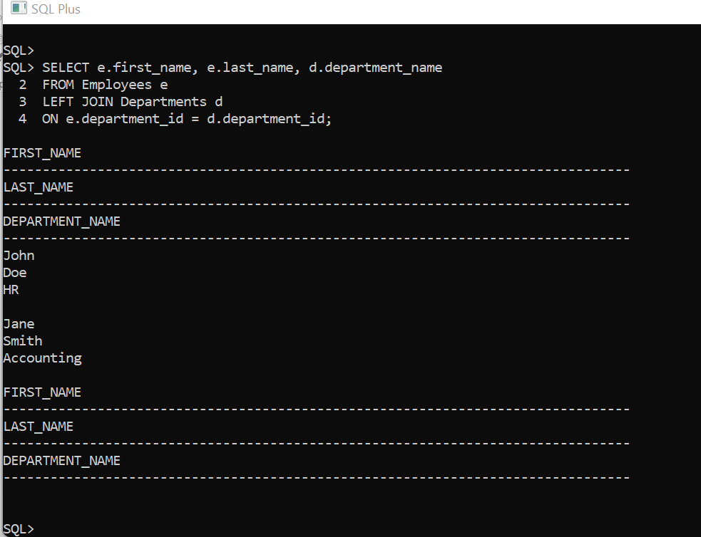

1. **Right join**

-- Retrieve all departments, including those that have no employees assigned

SELECT e.first_name, e.last_name, d.department_name

FROM Employees e

RIGHT JOIN Departments d

ON e.department_id = d.department_id;

1. **Full outer join**

-- Retrieve all employees and all departments, showing NULL where there is no match

SELECT e.first_name, e.last_name, d.department_name

FROM Employees e

FULL OUTER JOIN Departments d

ON e.department_id = d.department_id;

1. **Join with multiple tables**

-- Join Employees, Departments, and Salaries to show employee details, salary, and department

SELECT e.first_name, e.last_name, d.department_name, s.salary_amount

FROM Employees e

INNER JOIN Departments d

ON e.department_id = d.department_id

INNER JOIN Salaries s

ON e.employee_id = s.employee_id;

1. **Subquery with join**

-- Get employees whose salary is above the average salary

SELECT e.first_name, e.last_name, s.salary_amount

FROM Employees e

INNER JOIN Salaries s

ON e.employee_id = s.employee_id

WHERE s.salary_amount > (SELECT AVG(salary_amount) FROM Salaries);

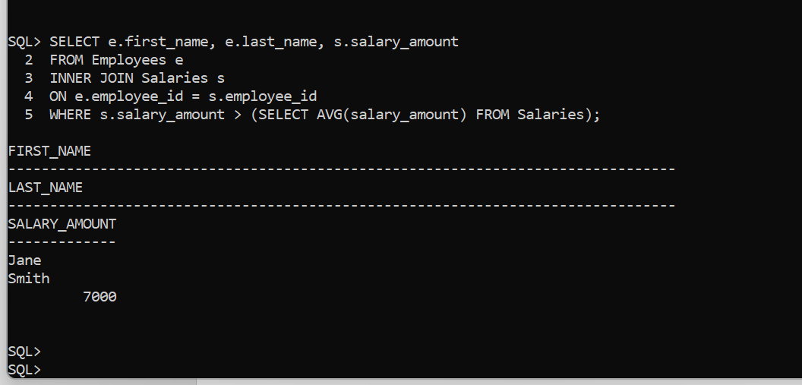

COMMIT; -- Save changes

-- or

ROLLBACK; -- Undo changes

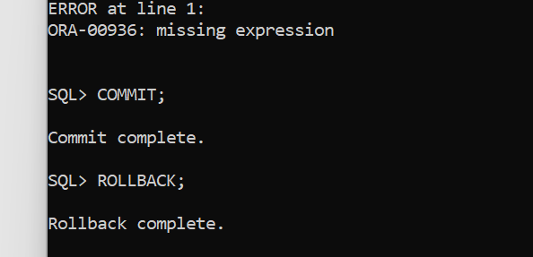

CREATE USER emp_user IDENTIFIED BY emp123;

GRANT CONNECT TO emp_user;

GRANT SELECT ON Departments TO emp_user;

GRANT INSERT ON Employees TO emp_user;

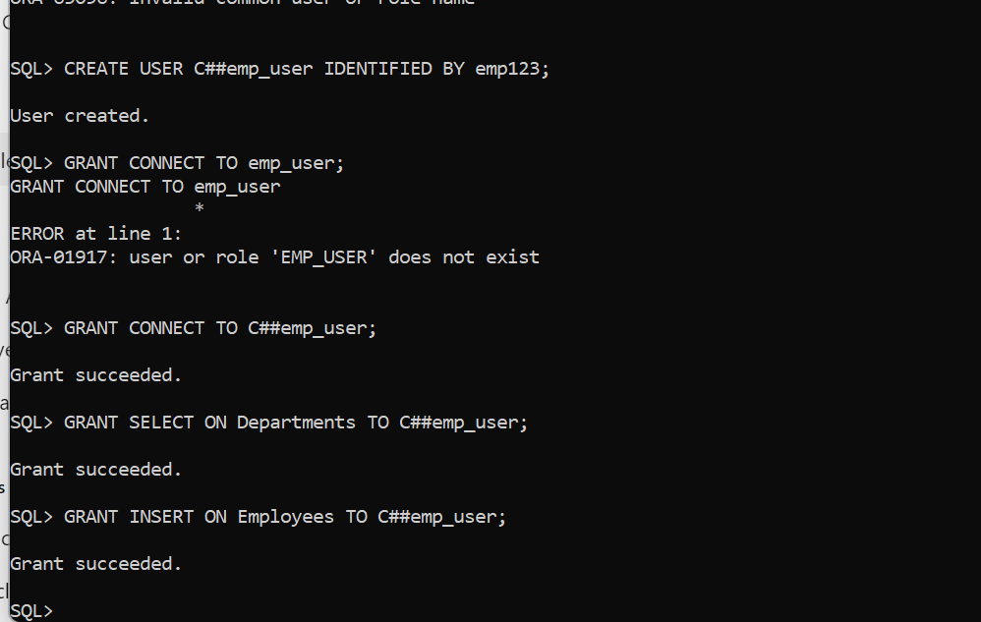

REVOKE INSERT ON Employees FROM emp_user;

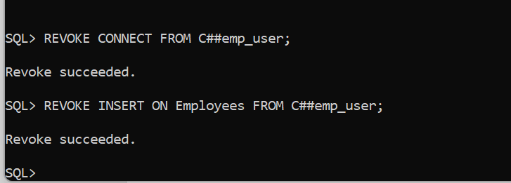

REFERENCES

1. Open ai